**Integrated Web-based Inventory Management System For Academic Institutions**

A Project Report submitted to the Department of Computer Science and Engineering, Jahangirnagar University in partial fulfillment of the requirements for the M.Sc. in Computer Science under PMSCS Program

By

Name: Md Nazmul Hasan

Student Id: CSE201903050

Session: Fall-2020

Supervised by

Dr. Md. Ezharul Islam

Associate Professor



DEPARTMENT OF COMPUTER SCIENCE AND ENGINEERING

JAHANGIRNAGAR UNIVERSITY

AUGUST 2021

**Abstract**

Inventory Management Software is important in every academic institution. Many corporate company has many assets but they don’t know what is the condition of their assets or how many assets are their. For this they need to manually count their assets. It aims to digitize any organization asset management system. Our Inventory Software provides information about number of items in department, we can see the stock report, any employee can request item such as a laptop through our application and there is an approval process in backend, After approval process, An employee will get his/her item.

In order to keep our application user friendly, I tried to add interactive UI design. It is fully secured application. Only authenticated user can use application. Initially I developed the app with the mandatory features only. It is a complete web based application developed with following technology (1) Programming Language – PHP, (2) Database – MySQL, (3) UI technology – Bootstrap 4, (4) Currently popular PHP framework – Laravel. All UI of this application is responsive so that any user from mobile browser can easily use this application. An honorable Teacher of CSE department first collect his/her user id and password from Inventory Manager. Then the can request for an item such as a laptop, chair or table etc. Inventory Manager can see their requested item and if item is available in inventories then they can approve the request or forward to Department chairman for higher level approval. After approved request, a user can get their item. Admin user can create user with room wise. The whole application contain role based permission. Admin user can create user with giving him permission to specific menu.

**Declaration**

I, hereby, declare that the work presented in the project entitled “**Integrated Web-based Inventory Management System For Academic Institutions**” is the outcome of the investigation performed by me under the supervision of Dr. Md. Ezharul Islam, Associate Professor, Department of Computer Science and Engineering, Jahangirnagar University, Savar, Dhaka, Bangladesh. I also declare that no part of this Project and thereof has been or is being submitted elsewhere for the award of any degree or diploma.

Countersigned

………………………

Md Nazmul Hasan

Id: CSE201903050

Department of Computer Science and Engineering

Jahangirnagar University

Saver, Dhaka, Bangladesh.

**APPROVAL OF ACCEPTANCE**

The Project Report entitled “**Integrated Web-based Inventory Management System For Academic Institutions**” submitted by **Md Nazmul Hasan**, ID. No: CSE201903050 to the PMSCS Program, Department of Computer Science and Engineering, Jahangirnagar University in the partial fulfillment of the requirements for the degree of Master of Science in Computer Science. This project is done under the supervision of **Dr. Md. Ezharul Islam**, Associate Professor, Department of Computer Science and Engineering, Jahangirnagar University.

We have examined this report and recommend its acceptance:

_ _ _ _ _ _ _ _ _ _ _ _ _ _ _ _ _ _ _ _ _ _ _ _ _ _ _ _ _ _ _ _ _ _ _ _

Supervisor & 1st Examiner 2nd Examiner

**Dr. Md. Ezharul Islam** **Sarnali Basak**

Associate Professor Assistant Professor

Department of CSE Department of CSE

Jahangirnagar University Jahangirnagar University

Accepted By

_ _ _ _ _ _ _ _ _ _ _ _ _ _ _ _

**Dr. Md. Golam Moazzam**

Professor

Coordinator, PMSCS Program

Department of CSE

Jahangirnagar University

# **Acknowledgment**

I would like to express my special thanks of gratitude to my teacher (Dr. Md. Ezharul Islam, Associate Professor, Dept. of CSE) for his enthusiasm, patience, insightful comments, helpful information, practical advice and unceasing ideas that have helped me tremendously at all times in my research and writing of this report. His immense knowledge, profound experience and professional expertise in information technologies has enabled me to complete this project successfully. Without his support and guidance, this project would not have been possible. I could not have imagined having a better supervisor in my study. Who gave me the golden opportunity to do this wonderful project on the topic (Integrated Web-based Inventory Management System For Academic Institutions)

# **Contents**

**Abstract 2**

**Declaration 3**

**Acknowledgment 5**

**1. Introduction** **8**

**2. Background Technologies and Literature Review** **10**

2.1 Background Technologies 10

2.2 Literature Review 13

**3. System Analysis**  **17**

3.1 The Problem Statement 17

3.1.1 The Problem 17

3.1.2 The Solution 17

3. 1.3 The Stakeholders 17

3. 1.4 The User Roles 17

3. 1.5 The Risks 17

3. 1.6 The Assumptions 18

3.2 The Solution Attributes 18

3.2.1 The Vision of the Solution 218

3.2.2 The Vision Statement 18

3.2.3 The Vision Statement Template 19

3.3 Types of Requirements 20

3.4 Users 20

3.5 List of Features of Inventory Management System 20

**4. System Design** **23**

4.1 Collecting data in the problem domain 23

4.2 Format of User Story 23

4.3 DFD (Data flow diagram) of System Users 24

4.4 Use Case Diagram 24

4.5 Database design 26

4.6 Data Dictionary 27

4.7 ER Diagram 35

**5. System Implementation And Evaluation** **36**

5.1 System Implementation And Evaluation 36

5.2 Identification / Clarification 36

5.3 Wire framing of Inventory Management System 37

5.4 Development Technologies 37

5.5 Application Screenshots 38

5.6 Identify your testers: Listen to them and incorporate relevant feedback 53

5.7 Release/Deploy the application 53

5.8 Upgrade your app with improvements and new features 53

**6. Conclusion** 54

6.1 Conclusion 54

6.2 Future Work 54

**References**  55

Chapter 1

# **Introduction**

Inventory Management System application has developed for any organization or education institution such as our CSE department, JU. It is a web based application. Users will be able to access the application from any computer or mobile device through their browser. The user- interface and experience is developed to consider user needs and requirements. The primary User roles are Teacher, Inventory Manager, Department Chairman and Admin.

With proper inventory system, we can see the available item in our stock easily and we can take decision if we need to buy any item.

An Inventory Management System also helps us to track the theft of item, providing valuable information about stock item and the need for theft-prevention systems.

By Inventory Management System we can find available item in stock with a simple database search.

Many corporate company has many assets but they don’t know what is the condition of their assets or how many assets are their. For this they need to manually count their assets.

It aims to digitize any organization asset management system. Our Inventory Software provides information about number of items in department, we can see the stock report, any employee can request item such as a laptop through our application and there is an approval process in backend, After approval process, An employee will get his/her item.

In order to keep our application user friendly, I tried to add interactive UI design. It is fully secured application. Only authenticated user can use application.

Initially We developed the app with the mandatory features only. It is a complete web based application developed with following technology (1) Programming Language – PHP, (2) Database – MySQL, (3) UI technology – Bootstrap 4, (4) Currently popular PHP framework – Laravel.

All UI of this application is responsive so that any user from mobile browser can easily use this application.

An honorable Teacher of CSE department first collect his/her user id and password from Inventory Manager. Then the can request for an item such as a laptop, chair or table etc.

Inventory Manager can see their requested item and if item is available in inventories then they can approve the request or forward to Department chairman for higher level approval.

After approved request, a user can get their item.

Admin user can create user with room wise. The whole application contain role based permission. Admin user can create user with giving him permission to specific menu.

Chapter 2

# **Background & Literature Review**

# **2.1 Background Technologies**

Inventories are essential for keeping the track of the assets, keep the asset distribution system intact. It aims to digitize any organization asset management system. Our Inventory Software provides information about number of items in department, we can see the stock report, any employee can request item such as a laptop through our application and there is an approval process in backend. Inventory is essential to organization for asset distribution activities. The management of an organization becomes very concerned in inventory stocks. Inventory is part of the company assets. The overview of inventory system is to maintain all transactions of inventory items with dynamic item configuration quickly and effectively. In a word the Inventory Management (IMS) module will save valuable time and increase users productivity and quality outputs.

Inventory Management System is developed by using these types of technologies such as

1. **Programming Language:** We used **PHP**. PHP is a popular open source programming language with many open-source tools and libraries . [1]
2. **Framework**: PHP Laravel MVC Framework. **Laravel** is a popular web application framework with PHP language. It has a popular community. It has millions of ready made libraries to use in project. It has wonderful artisan command console to interact with application with command. Laravel framework is highly secured than other PHP framework [8]
3. **Database**: MySQL. **MySQL** is the most popular Open Source Relational SQL database management system. MySQL is one of the best RDBMS being used for developing web-based software applications. [1]
4. **Frontend :** HTML5, JavaScript framework; CSS3, Bootstrap 4**.**
5. **Code Editor: Visual Studio Code** is a code editor redefined and optimized for building and debugging modern web and cloud applications.
6. **Operating System**: Windows, Linux, MacOS

**Identify best design pattern to develop the application – Model View Controller(MVC)**

Identify best design pattern is important to develop a successful application. We should select right code architecture so that our code will be reusable, modular and easily refactor.

The most popular architecture choices are:

Model View Controller (MVC) [11]

**The Model View Controller (MVC) architecture for PHP**

The **Model-View-Controller (MVC)** is a popular design pattern used for developing web based application. To develop an web-based application with all popular language such as PHP, Java, C# we used MVC architecture.

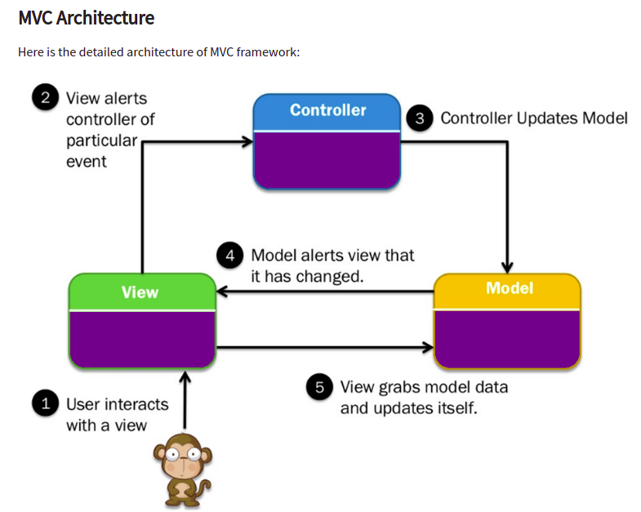

Figure 2.1: MVC Architecture Diagram.

### **The view**

A View is an output or the presentation of data to the user. For example, our item information view shows the item name text box, item category dropdown, etc.

**The Controller**

The Controller is handles the user interaction. Controller request data from model and send that data to view.

**The model**

The model stores data and interact with database. We can put all the business logic of application in model. Model gives data to controller when controller request.

# **2.2 Literature Review**

An Inventory Management System helps us to track the theft of item, providing valuable information about stock item and the need for theft-prevention systems.

By Inventory Management System we can find available item in stock with a simple database search.

Many corporate company has many assets but they don’t know what is the condition of their assets or how many assets are their. For this they need to manually count their assets

Inventory management is considered as major concerns of every organization.

Some existing Inventory Management System Features are given below

**1. bdtask Inventory Management System**: BDTask is Bangladeshi software company. They have Inventory Management System with following features

- User management, Role and Permission management, Customer management, Supplier management, Stock management, Sale management

The following figure shows the stock report in bdtask inventory management system

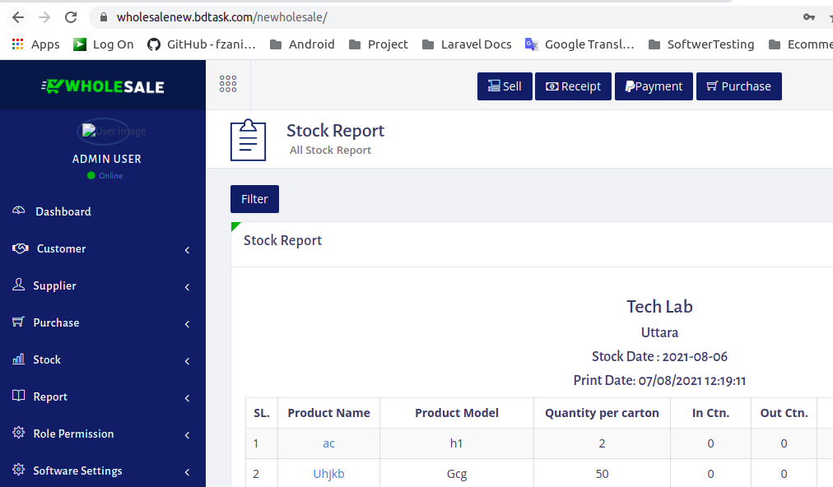Figure: bdtask Inventory Management System

**2. Odoo ERP Inventory Management System**: Odoo is a suite of business management software tools including, inventory management. They have the following features in Inventory Management System.

- Product management

- Inventory adjustment

- Product transfer

- Warehouse management

- Product category and

- Various reports.

The following figure shows Product Entry page in Odoo ERP Inventory Management System

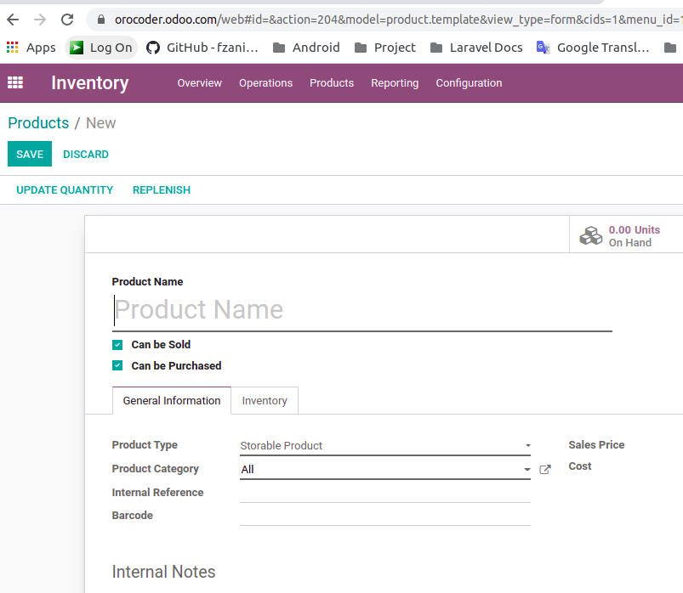Figure: Odoo ERP Inventory Management System

**2. BASE IT Inventory Management System**: Base IT is leading IT firm in Bangladesh. They have an Inventory Management System with following features.

- Product category, Product entry, Purchase Requisition, Purchase Payment, All purchase view, Purchase due payment, Sales details, Stock report, Branch sales details and other reports.

Many corporate company has many assets but they don’t know what is the condition of their assets or how many assets are their. For this they need to manually count their assets.

Some organization asset management system are given below:

**1. TechnoVista Ltd – a Software Company:** Our company has many assets such as Computer, Printer, Photocopy Machine, laptop bag, Chair, Table and many more assets. But they maintain manual system such as note book to count their assets. Even If anyone take any item such as laptop for COVID situation in home for Work from home office, They don’t know who took which laptop. They have no Integrated Inventory Management System to quickly know the condition of their assets.

**2. Department of CSE**, **JU**: Jahangirnagar University CSE department has no integrated Inventory Management System to keep track the flow of their asset management system. They need to count manually which Item (Laptop, Desktop, Furniture or any other computer accessories) allotted to which teacher or employee. If they use Inventory Management System, then they easily can find the report of asset distribution by one click.

Benefits of using Our Inventory Management System(IMS):

* Application is Dual Language such as English and Bangla
* Dynamic Item Category configuration
* Dynamic item configuration
* Item purchase.
* Item request by department teacher or other employee.
* Item issue as per requested
* Item issue approval process.
* Item stock report
* Asset Location (Room) wise stock report
* Item allocation to Teacher information
* Employee wise item allocation information.
* Item return to custodian information.
* Approval flow for allocation item to employee such as teacher, students
* Supplier Information
* Item purchase from supplier information.
* Employee Information
* All report can be download as PDF, Word or Excel format.
* User activity log.
* Interactive user interface.

And Many more features

Chapter 3

# **System Analysis**

# **Problem Statement**

* + 1. **The Problem:** Many academic institution has many assets but they don’t know what is the condition of their assets or how many assets are their. For this they need to manually count their assets.

For example, A company has many assets such as Computer, Printer, Photocopy Machine, laptop bag, Chair, Table and many more assets. But they maintain manual system such as note book to count their assets. Even If anyone take any item such as laptop for COVID situation in home for Work from home office, They don’t know who took which laptop.

They have no Integrated Inventory Management System to quickly know the condition of their assets. Many Company or Educational institution as like CSE department, JU has same situation. In CSE Department, JU has no Integrated Inventory Management System to quickly know the Stock report , asset distribution status

* + 1. **The Solution:** The Inventory Management System is complete solution to mange asset distribution flow and It has various report to know the current stock status report, Item Information, Item requisition etc
    2. **Stakeholders:** Inventory Manager, Employe, Teacher of CSE department.
    3. **User Roles:** Multiple type of user roles have to to be created for the better accessing end user through the system.
    4. **Risks:** Unclear about the following issues what constitutes for latest technologies?
* What will happen for Multiple department stock report?
* What will happen if we provide the wrong information?
* How to dispose bad condition item?
* How to notify for new Item request
* To the system cannot work
  + 1. **Assumptions:** Some obvious **assumptions**
* Inventory Manager may inexpert, Intermediate and expert person
* Item category Content
* users of Inventory Management System have an alternative way when system will not work properly.
* For the (chosen) solution to work, the following assumption is required even though we have no control of it.
  + - If unwanted situation is created to the system, then must be recovery to the system for users.
* Check the validity of the above assumptions.

# **Solution attributes**

* For sound knowledge for using web based application
  + Participate in UAT.
  + Supply UAT training materials (Manual, video etc)
  + Admin can entry for an item request to the system on behalf of a teacher
* Characteristics of the provided information
  + Monitoring dashboard will help to the authority of Inventory Management System application
  + Simple and Clear
* All of these attributes reflect *decisions* made by management team and authority of sound system (i.e. user) or by the solution developer
  + 1. **Vision of the Solution:** Vision of the solution objectives are.
* Eliminate Redundant Work
* Data Sharing instantly everywhere.
* Increase Accuracy through validation & instruction.
* Personal Assistance using reminder & alert
  + 1. **Vision statement:** Inventory Management System is passionate about excellence asset management system where automation system will address to the overall process of asset distribution through the dedicated features.
    2. **Vision Statement Template:**

It aims to Cover the essence of the new system Market the software Keep the developers focused on the “core” essence of the system It should be brief

The various parts of a general vision statement are:

--**For** (target user, audience)

--**Who** (statement of the need or opportunity)

--**The** (product name) is a (product category)

--**That** (key benefit, compelling reason to build/buy)

--**Unlike** (primary competitive alternative)

--**Our product** (statement of primary differentiation)

**Vision Statement Template for Inventory Management System:**

|  |  |
| --- | --- |
| **For** | Academic Institutions |
| **Who** | Have difficulty in asset distribution |
| **The Integrated Web-based Inventory Management System for academic institution** | is a Web based application |
| **That** | provides the ability to distribute Items among employee |
| **Unlike** | Currently available systems that have poor interface  or many organization have no integrated system. |
| **Our product** | Our Inventory Management System is custom dynamic and Interactive user interface to properly distribute Item among Teachers or other employee and can find stock report |

Vision statement template of Inventory Management System

# **3.3 Types of Requirements**

**Functional requirements**: Describe the application main features

All requirements of three phases are functional requirements

**Nonfunctional requirements**:

* The response time of a system must be less than 2 second
* The system gives a message when after a transaction.
* The system behavior for large database

**Constraints** (“Pseudo requirements”): Imposed by the client or the environment in which the system will operate

The implementation language must be PHP

# **3.4 Users**

* Admin
* Inventory Manager
* Teacher
* Department Chairman and any other employee of department

# **3.5 List of Features of Inventory Management System**

* + 1. Dynamic user management system
    2. User Role and Permission management system.
    3. Dynamic setup data configuration system.
    4. Employee information
    5. Responsive design
    6. Login
    7. Sign out.
    8. Forget password
    9. User profile.
    10. Item categories configuration.
    11. Dynamic Item configuration.
    12. Supplier information.
    13. Item purchase from supplier.
    14. Item request system.
    15. Requested Item approval process.
    16. Allot requested item to employee.
    17. Return Item to Inventory manager.
    18. Stock Report.
    19. Asset location (Room) wise Item stock report.
    20. User activity report .
    21. All report can be download as PDF, Word or Excel format.
    22. User friendly Filter system to search item.
    23. Interactive UI design.

Scope of phased release:There is three-phase release to the Inventory System. These are

|  |  |  |
| --- | --- | --- |
| **Phase 1** | **Phase 2** | **Phase 3** |
| 1. Inventory Management System template design. 2. Completed database design. 3. Fixing sidebar for different type of role 4. Responsive design 5. Registration 6. Login 7. Sign out 8. Forget password | 1. Employee information setup. 2. User’s role and permission system setup 3. Both Bangla and English language switcher in whole application 4. Fixing Architecture 5. Main dashboard design. 6. Develop user activity report. 7. Common setup data configuration setup 8. Item categories setup 9. Developed Item setup 10. Supplier information setup. | 1. Developed Item receive from supplier scope. 2. Developed Item request system 3. Developed Approval process on requested item. 4. Developed Item receive scope. 5. Developed Item return scope 6. Developed Stock report 7. Asset location wise stock report 8. Bug fixing 9. Incorporate feedback. |

Chapter 4

# **System Design**

# **4.1 Collecting Data in the Problem Domain**

To understand the problem of Inventory Management system that we are dealing with, we can adopt the following techniques

– Analysis Asset management system in various organization

– Questionnaire

– Experimentation by building a prototype

– Observation

– Document inspection

– User story

# **4.2 Format of User Story**

User Story format is chosen for Inventory Management System. The format of the User Story is as follows:

1. As a Admin I need Access dashboard So that Monitoring the data.
2. As a registered user, I am required to login so that I can access the system.
3. As a forgetful user, I can request a password reminder I can login if I forgot mine.
4. As a teacher, I want to request for an Item so that I can use that Item.
5. As an Inventory Manager, I want to receive purchased Item from supplier so that I can view stock report easily.
6. As a department chairman, I want to see stock report so that I can now the current asset distribution.
7. As an Admin, I want to add Item Category so that I can use that in item setup.
8. As an Admin, I want to add Item information so that I can get item wise report.

# **4.3 Data Flow Diagram (DFD)**

The figure 4.1 shows the data flow diagram of the system. Here we see that Inventory manager purchase product or items from suppliers and at a time stock is increased. Then an employee request for an item then inventory manager approved item

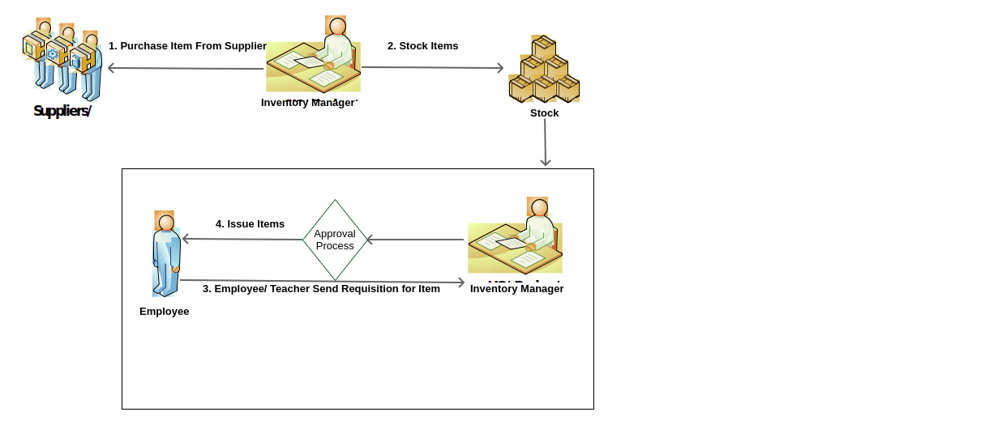Figure 4.1: DFD diagram of Item Purchase and Item Request by Teacher

The figure 4.2 shows the full inventory management system features with data flow diagram.

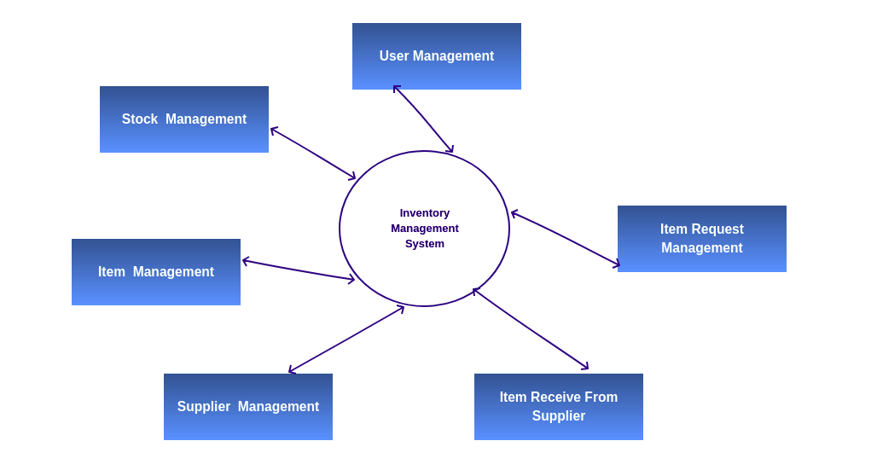Figure 4.2: DFD diagram of Full Inventory System

# **4.4 Use Case Diagram for Inventory System**

The figure 4.3 shows the Use Case diagram with a set of use case and actors and their relationships for Inventory Management System

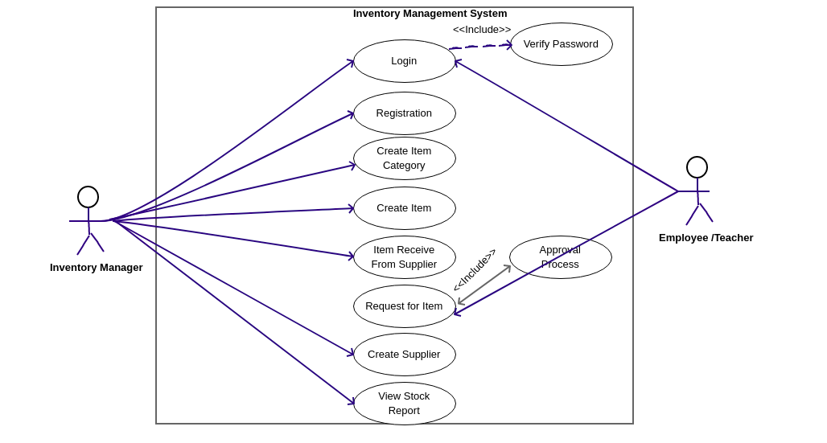Figure 4.3: Use Case Diagram

# **4.5 Database Design of Inventory Management System**

Database design is the most important part of system design. All activities of users store by using database.

# **4.6 Data Dictionary of Inventory Management System**

**Table Name** : users

**Primary Key** : id

|  |  |  |  |
| --- | --- | --- | --- |
| **Name of Attribute**  ***(Bangla Name)*** | **Description**  ***(field level Business Rule)*** | **Data Type**  ***( Field Size)*** | **Mandatory/**  **Optional** |
| Name English | Text | Text (100) | M |
| Name Bangla | Text | Text (100) | M |
| Login Id | Text | Text (20) | M |
| Password | Encrypted/Hashed text, validated with confirm password.  Password must contain combination of [Aa-Zz], [0-9] and at least one special character | Text (100) | M |
| Email | Valid Email Address | Text (50) | M |
| Mobile No. | Text | Text (20) | O |
|  |  |  |  |
| Is Active (সক্রিয়) | Yes (হ্যাঁ) or No (না) | Boolean | M |
| User Level | Text | Text (100) | O |
| Designation | Derived from designation setup | int | O |
| Location | Asset Location. Ex. Room No 1 | int | O |
| Blood Group | Blood group | Text (100) | O |
| **Role [Multiple]** |  |  |  |
| Role Id | Derived from Role | Number(FK) | O |

**Table Name** : inv_item_information

**Primary Key** : id

|  |  |  |  |
| --- | --- | --- | --- |
| **Name of Attribute**  ***(Bangla Name)*** | **Description**  ***(field level Business Rule)*** | **Data Type**  ***( Field Size)*** | **Mandatory/**  **Optional** |
| Name (নাম) | Unique text | Text (100) | M |
| Name in Bangla (নাম বাংলায়) | Text | Unicode Text (100) | O |
| Code (কোড) | Unique text like: "JU-001" | Text (20) | M |
| Code in Bangla (কোড বাংলায়) | Text | Unicode Text (20) | O |
| Asset Type | Derived[cc] Fixed Asset, Accessories, Consumable/Moveable | Number (FK) | M |
| Category | Derived from Category | Number (FK) | M |
| UoM | Derived[cc] from Unit of Measurement | Number (FK) | O |
| Manufacturer | Derived[cc] from Manufacturer | Number (FK) | O |
| Model | Text | Text (100) | O |
| Part Number | Text | Text (100) | O |
| Minimum Re-order qty. | Minimum re-order quantity | Number(10) | O |
| Is Serialized | Default false, if true serial is required for all further transactions | Boolean | M |
| Is Active | Default true, if false will not available in further "Add New" transactions | Boolean | M |
| Remarks | Text | Text (200) | O |

**Table Name** : inv_item_category_sub_category_information

**Primary Key** : id

|  |  |  |  |
| --- | --- | --- | --- |
| **Name of Attribute**  ***(Bangla Name)*** | **Description**  ***(field level Business Rule)*** | **Data Type**  ***( Field Size)*** | **Mandatory/**  **Optional** |
| Name (নাম) | Unique text like "Computer, Air Condition (A/C)" | Text (100) | M |
| Name in Bangla (নাম বাংলায়) | Text | Unicode Text (100) | M |
| Code (কোড) | Unique text like: "AC" | Text (20) | O |
| Code in Bangla (কোড বাংলায়) | Text | Unicode Text (20) | O |
| Remarks | Text | Text (200) | O |

**Table Name** : inv_item_receive_from_supplier_information

**Primary Key** : id

|  |  |  |  |
| --- | --- | --- | --- |
| **Name of Attribute**  ***(Bangla Name)*** | **Description**  ***(field level Business Rule)*** | **Data Type**  ***( Field Size)*** | **Mandatory/**  **Optional** |
| Receive ID | Unique, auto generated from DB-PK | Text (100) | M |
| Receive Date | Date | Date | M |
|  |  |  |  |
| Supplier | Derived from Supplier | Number(FK) | M |
|  |  |  |  |
| PO Number | Either Package-Lot number or unique PO if purchased directly without Package  [Optional for Accessories] | Text (20) | M |
| Invoice Number | Text | Text(50) | O |
| Invoice Date | Date | Date | O |
| Received By | Logged in User Id | Number(FK) | O |
| Remarks | Text | Text (200) | O |
| **Item Detail Information [Multiple]** | | | |
| Item Id | Derived Item from Package-Lot or Search Items UI | Number(FK) | M |
| Item Status | Derived from Item Status, default value is 1=Good (Is-Good) | Number(FK) | M |
| Quantity |  | Number(10) | M |
| Serial | Mandatory for Fixed Asset and Is-Serialized items | Text (50) | O |
| Fixed Asset ID |  | Text (50) | O |
| Remarks |  | Text (100) | O |
| **Update Current Stock** | | | |
|  |  |  |  |

**Table Name** : inv_request_items

**Primary Key** : id

|  |  |  |  |
| --- | --- | --- | --- |
| **Name of Attribute**  ***(Bangla Name)*** | **Description**  ***(field level Business Rule)*** | **Data Type**  ***( Field Size)*** | **Mandatory/**  **Optional** |
| Receive ID | Unique, auto generated from DB-PK | Text (100) | M |
| Request Date | Date | Date | M |
| Receive Date | Date | Date | M |
| Location | Derived from Asset location setup | Number(FK) | M |
| is_requested | 0 or 1 | tinyint(4) | M |
| is_approved | 0 or 1 | tinyint(4) | M |
| is_received | 0 or 1 | tinyint(4) | M |
| Requested By | Logged in User Id | Number(FK) | O |
| Approved By | Logged in User Id | Number(FK) | O |
| Received By | Logged in User Id | Number(FK) | O |
| Remarks | Text | Text (200) | O |
| **Item Detail Information [Multiple]** | | | |
| Item Id | Derived Item from Package-Lot or Search Items UI | Number(FK) | M |
| Item Status | Derived from Item Status, default value is 1=Good (Is-Good) | Number(FK) | M |
| Quantity |  | Number(10) | M |
| Serial | Mandatory for Fixed Asset and Is-Serialized items | Text (50) | O |
| Fixed Asset ID |  | Text (50) | O |
| Remarks |  | Text (100) | O |
| **Update Current Stock** | | | |
|  |  |  |  |

**Table Name** : inv_suppliers

**Primary Key** : id

|  |  |  |  |
| --- | --- | --- | --- |
| **Name of Attribute**  ***(Bangla Name)*** | **Description**  ***(field level Business Rule)*** | **Data Type**  ***( Field Size)*** | **Mandatory/**  **Optional** |
| Name (নাম) | Unique text | Text (100) | M |
| Name in Bangla (নাম বাংলায়) | Text | Unicode Text (100) | O |
| Code (কোড) | Unique text like: "JU-001" | Text (20) | M |
| Code in Bangla (কোড বাংলায়) | Text | Unicode Text (20) | O |
| Contact No | Text | Text (20) | M |
| Email | Valid Email | Text (20) | O |
| Website | Website | Text (20) | O |
| Address | Supplier Address | Text | M |
|  |  |  |  |
| Remarks | Text | Text (200) | O |

**Table Name** : inv_return_items

**Primary Key** : id

|  |  |  |  |
| --- | --- | --- | --- |
| **Name of Attribute**  ***(Bangla Name)*** | **Description**  ***(field level Business Rule)*** | **Data Type**  ***( Field Size)*** | **Mandatory/**  **Optional** |
| Returned Date | Date | Date | M |
| Created Date | Date | Date | O |
| Created By | Logged in User Id | Number(FK) | O |
| Remarks | Text | Text (200) | O |
| **Item Detail Information [Multiple]** | | | |
| Item Id | Derived Item from Package-Lot or Search Items UI | Number(FK) | M |
| Item Status | Derived from Item Status, default value is 1=Good (Is-Good) | Number(FK) | M |
| Quantity |  | Number(10) | M |
| Serial | Mandatory for Fixed Asset and Is-Serialized items | Text (50) | O |
| Fixed Asset ID |  | Text (50) | O |
| Remarks |  | Text (100) | O |
| **Update Current Stock** | | | |
|  |  |  |  |

**Table Name** : employees

**Primary Key** : id

|  |  |  |  |
| --- | --- | --- | --- |
| **Name of Attribute** | **Description**  ***(field level Business Rule)*** | **Data Type**  ***( Field Size)*** | **Mandatory/**  **Optional** |
| Employee ID |  | Text (10) | M |
| Employee Name (In English) |  | Text (100) | M |
| Employee Name (In Bangla) |  | Text (100) | M |
| Employee Photo |  | Image | O |
| Date of Birth |  | Date | M |
| Father's Name |  | Text (100) | O |
| Mother's Name |  | Text (100) | O |
| Gender | Derived (Male/Female) | Text (20) | M |
| Mobile |  | Text (15) | O |
| Religion | Derived | Text (20) | M |
| Designation | Derived (Ex: Senior Officer) | Text (50) | O |
| Employee Type | Derived (Ex: Officer) | Text (100) | M |
| Employee Category | Derived (Ex: Contractual) | Text (100) | M |
| Employee Class | Derived | Text (10) | M |
| Joining Date | Date and Time | Date | M |
| Release/Resign/Retirement Date | Date and Time | Date | O |
| Is Active | Yes or No | Boolean | M |
| Picture |  | Image | O |

**Table Name** : access_logs

**Primary Key :** id

|  |  |  |  |
| --- | --- | --- | --- |
| **Name of Attribute** | **Description**  ***(field level Business Rule)*** | **Data Type**  ***( Field Size)*** | **Mandatory/**  **Optional** |
| User Id | Logged In User | INT | M |
| Login IP |  | Text (100) | M |
| Login Datetime |  | date | M |
| Logout Datetime |  | date | O |
| User Agent | Browser Info | Text | M |

**Table Name** : common_labels

**Primary Key** : id

|  |  |  |  |
| --- | --- | --- | --- |
| **Name of Attribute** | **Description**  ***(field level Business Rule)*** | **Data Type**  ***( Field Size)*** | **Mandatory/**  **Optional** |
| Data Type | type of data used to categorize content | Text | M |
| Name English |  | Text (100) | M |
| Name Bangla |  | TEXT(100) | M |
| Order |  | int | O |
| Status | 0 or 1 | tinyint(1) | M |

# **4.7 ER-Diagram of Inventory Management System**

The figure 4.4 shows the Entity Relationship Diagram (ERD) for inventory management system. We can see the all entity of Inventory system with their attributes and relationship among entity

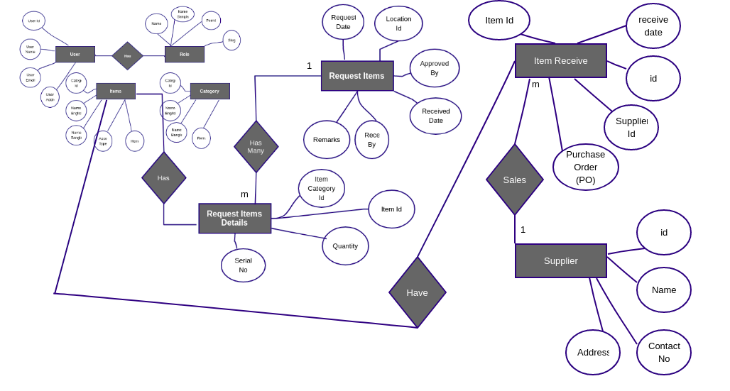Figure 4.4: ER-Diagram for whole Inventory System

Chapter 5

# **System Implementation and Evaluation**

# **5.1: A successful application starts with a proper idea**

To create a successful application, the first thing we need to keep in mind is:

**Identify a problem which can be resolved by our application:** Inventory Management System(IMS) has been developed for mid or large Organization and Institution to manage their asset distribution. Users will be able to access the application on Laptop and Desktop computer and android devices (smartphones or tablets) through Browser(Firefox, Google Chrome etc). The user- interface and experience is developed to consider user needs and requirements. User roles are Inventory Manager, Dept. Chairman, Other Teacher of CSE dept, JU and Admin:

The application should provide an organization/institution like our University with tangible benefits including Item distribution, Item stock report, Employee database etc.

# **5.2: Identification / Clarification**

To create a successful application, we need to identify or be clear about:

• **Application target users** – An application should always be developed keeping in mind the target users of an application. So to the Inventory Management System application users are Inventory Manager and Other top management of organization and Admin

• **Multiple OS and devices to be supported** – An web application should be supported in Latest version of all popular browser.

• **Interactive User Friendly UI** – An web application User Interface (UI) should be user friendly and mobile responsive so that user easily can use it.

• **Load Balancing**– When we start develop an web application, we need to keep in mind that our application should work properly for large scale data and many user.

# **5.3: Wire framing of Inventory Management System Application**

Designing our application is another important factor responsible for success of an application. Remember, a good UX design and good UI-UX means good discover ability. An application developer should concentrate on the UI design and consider platform design standards as well. Today if UI design of an application is beautiful and mobile responsive, then the application will be successful application.

# **5.4: Development Technology**

|  |  |
| --- | --- |
| **Purpose** | **Tools & Technologies** |
| Backend Programming | PHP, PHP Laravel MVC Framework |
| Web Server | Apache |
| Database | MySQL |
| Front-End | HTML, CSS, JavaScript, Jquery, Bootstrap |
| Operating System | Windows, Linux, MacOS |
| Browser | Firefox, Google Chrome, Opera, Safari |
| Design | UML, Pencil, Photoshop etc. |

# **5.5 Application Screenshots**

**Login Screen:** After entering username and password in login screen, user will be redirect to dashboard if username and password is correct. If username or password is wrong then will through error message

|  |
| --- |
|  |

Figure 5.1: Login screen

**Main Dashboard:** User will be redirect to this dashboard after successful login. In sidebar, there is User management menu and Settings menu and in body of page there is Inventory module and user management shortcut icon.

|  |
| --- |
|  |

Figure 5.2: Main Dashboard

**User List:** Whole system users is in this list. From this list we can create new user or edit existing user and also delete existing user. We can also assign user role and permission.

|  |
| --- |
|  |
|  |

**Figure 3: User List and User Entry**

Figure 5.3: User List and Entry form

**User Role:** Assign user role from this menu. We can create new role or update existing role.

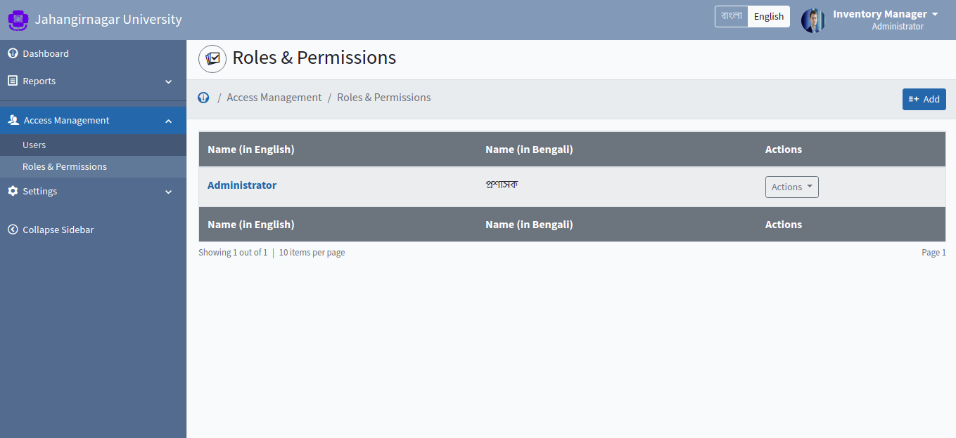

Figure 5.4: User Role and Permission

**Common Labels:** Whole system common setup data is here. From this menu any one can add or update setup data

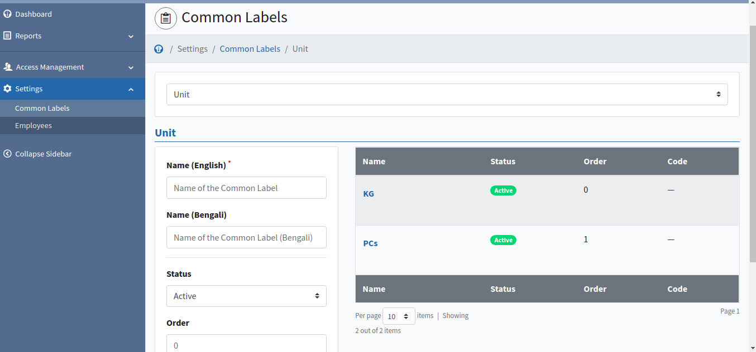Figure 5.5: Common Setup Data Screen

**Employees:** Employee information is in this menu. We can create new employee and edit existing employee information. We also view employee information

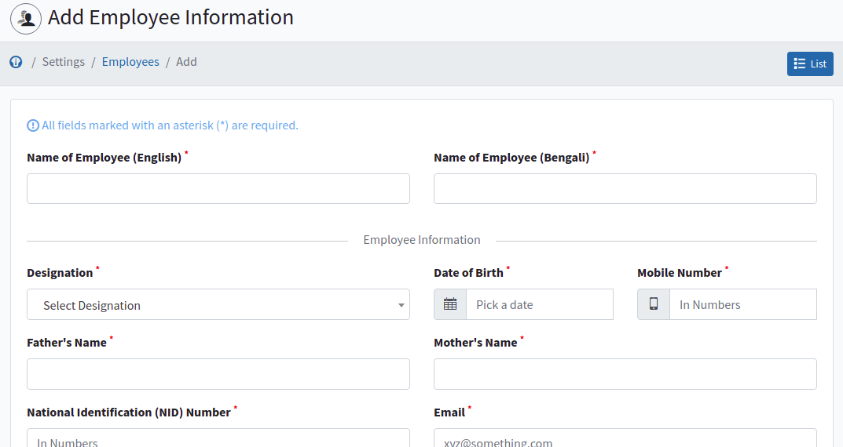

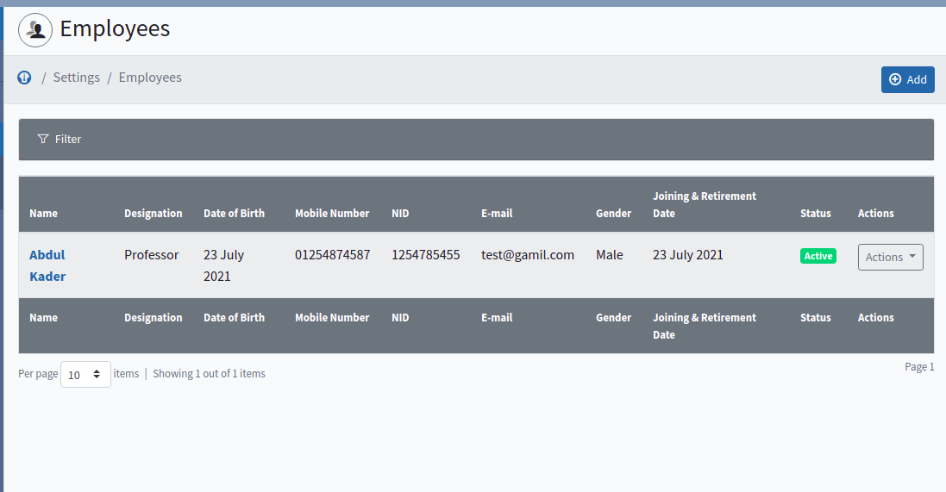Figure 5.6: Employee List and Employee Entry form

**Item Category:** Item category list is here. New Item category will be inserted from this menu and update existing category. Category name will be both English & Bangla.

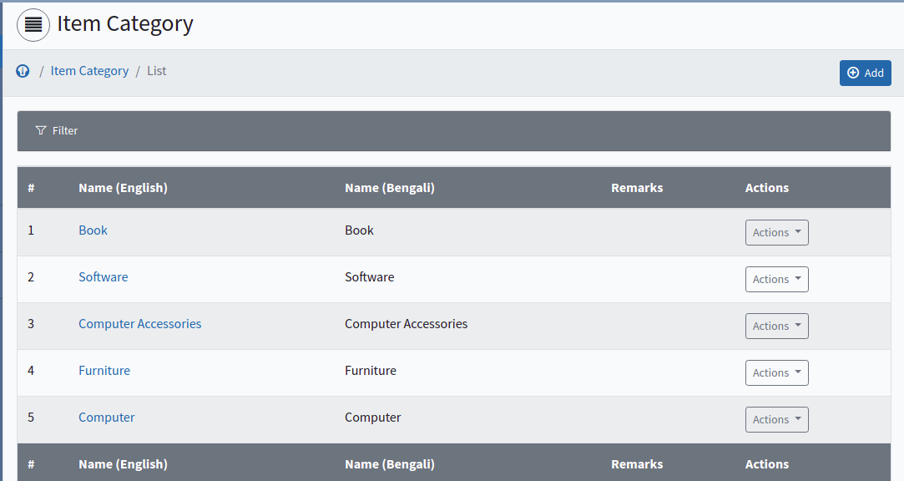

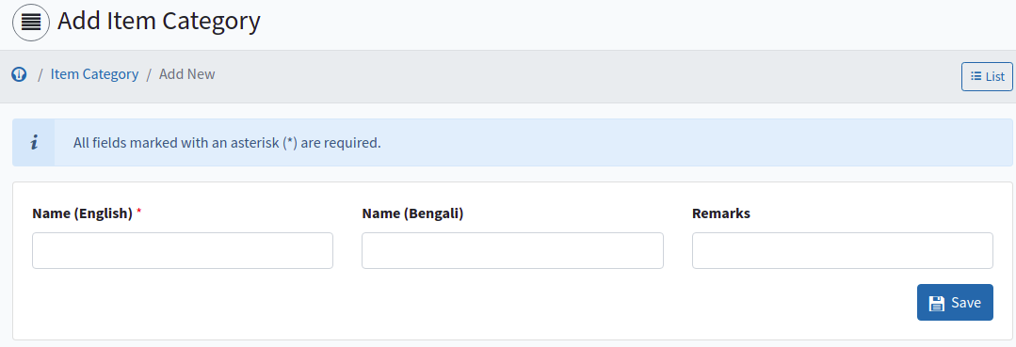

Figure 5.7: Item Category List and Entry form

**Item:** We can create or update Category Wise Item

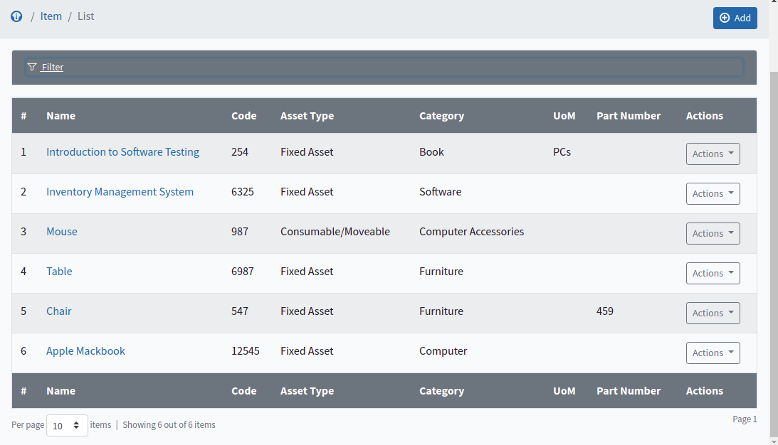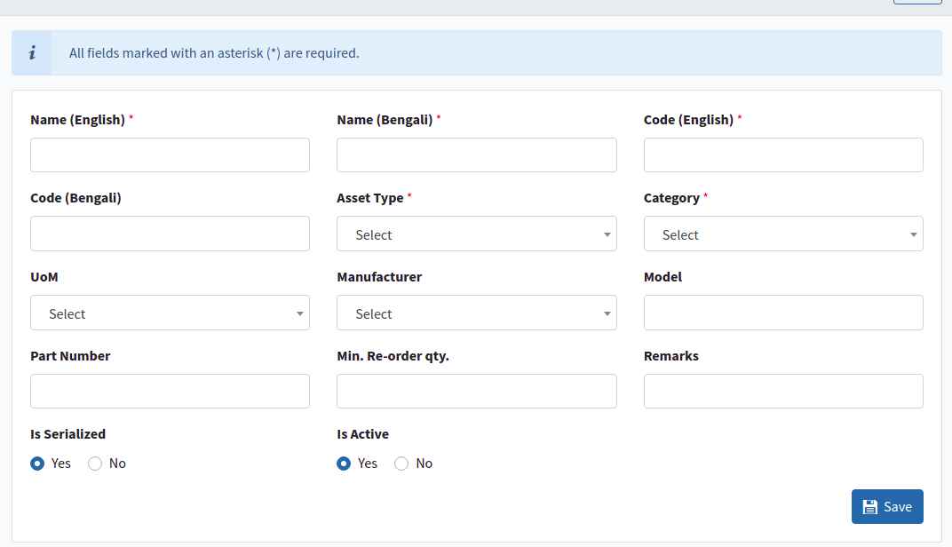

Figure 5.8: Item List and Item Entry form

**Item Receive from Supplier:** Enter new purchased item in this menu. This menu shows the Item receive from supplier list.

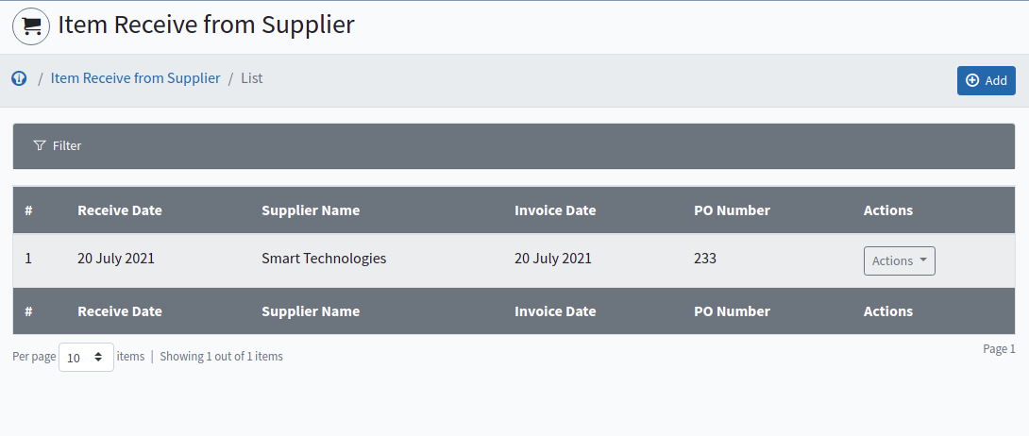

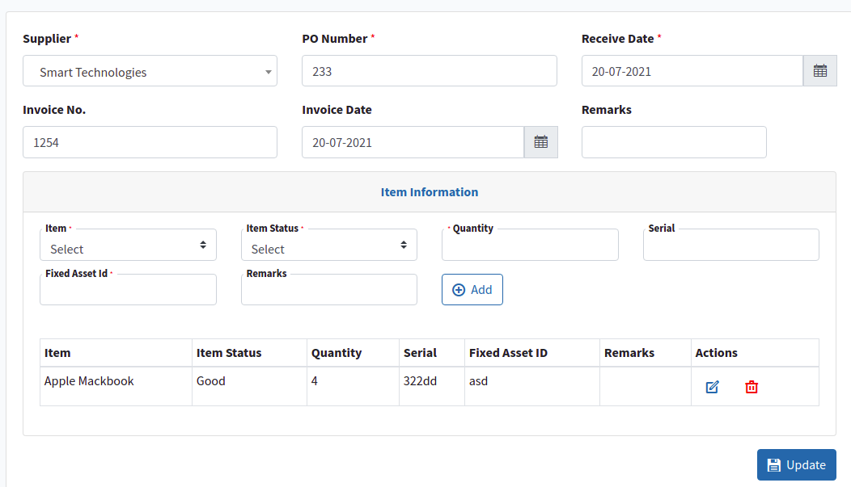Figure 5.9: Item Receive from Supplier List and Entry form

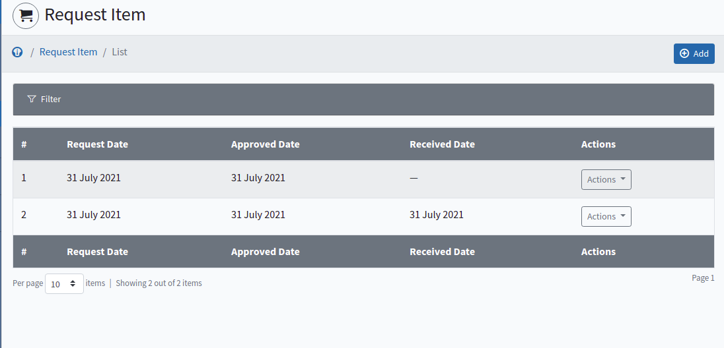**Item Request:** Any employee or teacher can request for Item. The following figure shows the Item request list and entry from

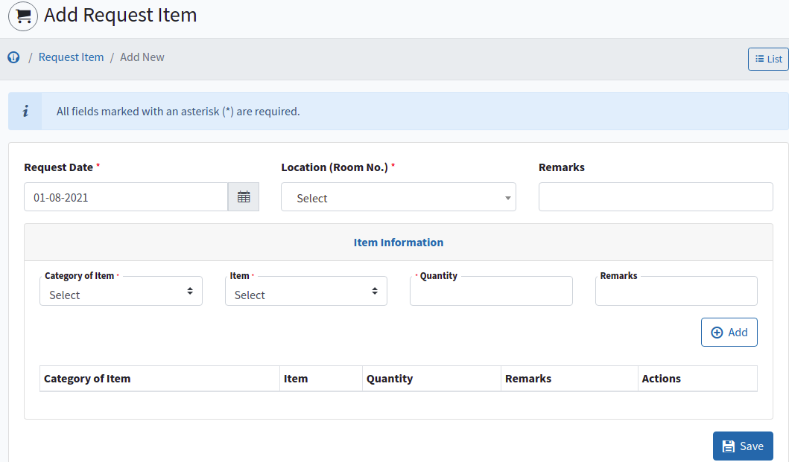Figure 5.10: Request for Item List and Request Page

**Item Request Approval process:** Admin user or top management approve requested item. There is a dynamic approval process.

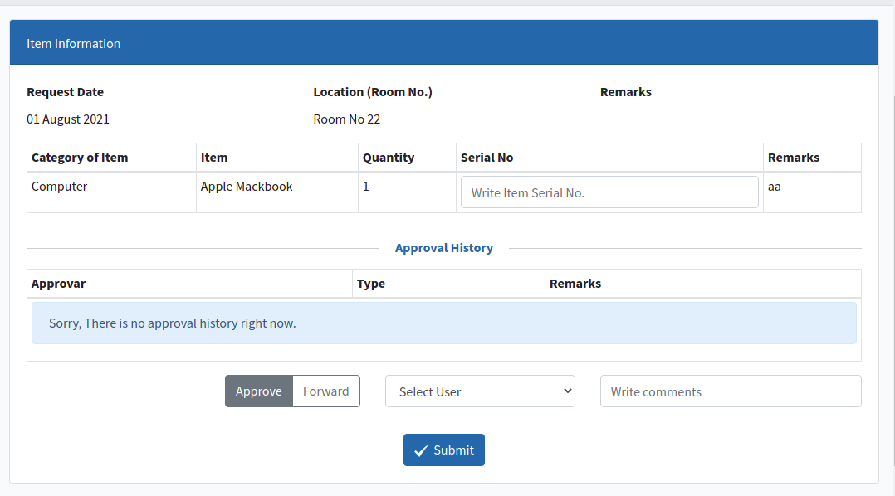

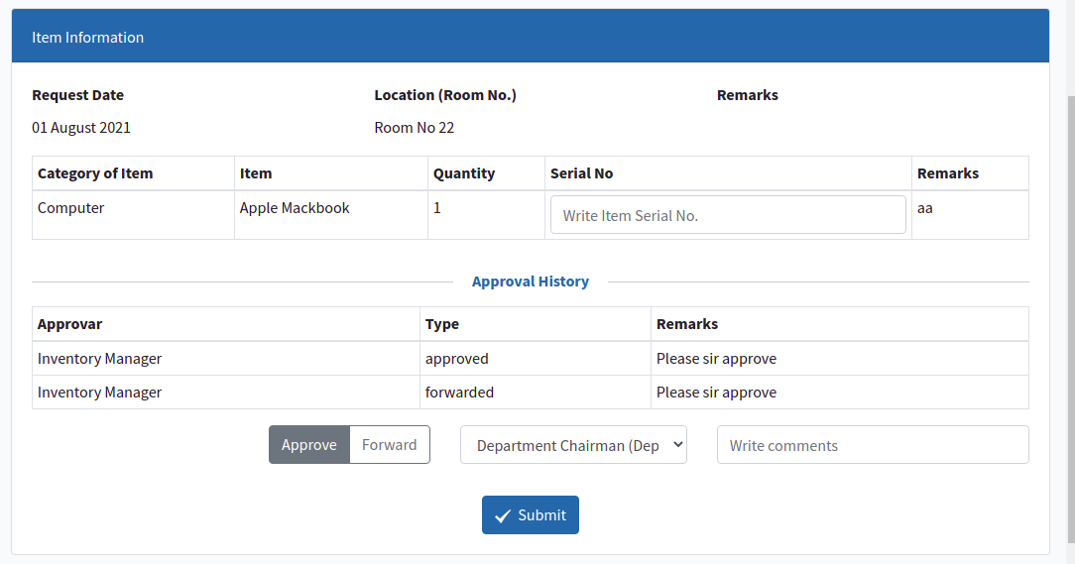Figure 5.11: Requested Item Approval Process page

**Item Return:** Any user can return their allocated item by this scope.

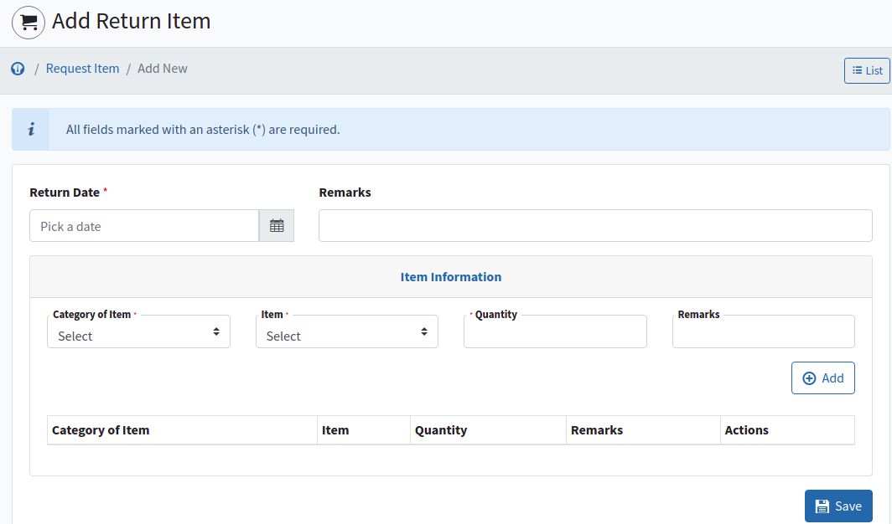

Figure 5.12: Item Return screen

The figure 5.13 shows the supplier information list. We can create new supplier info or update existing supplier from this scope.

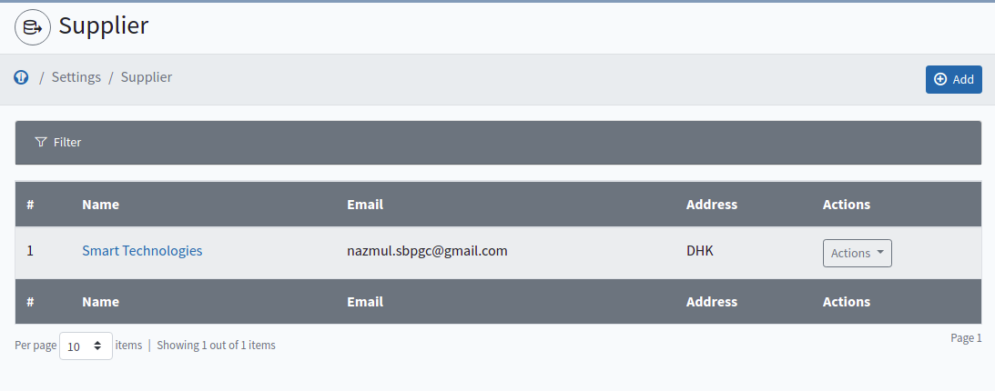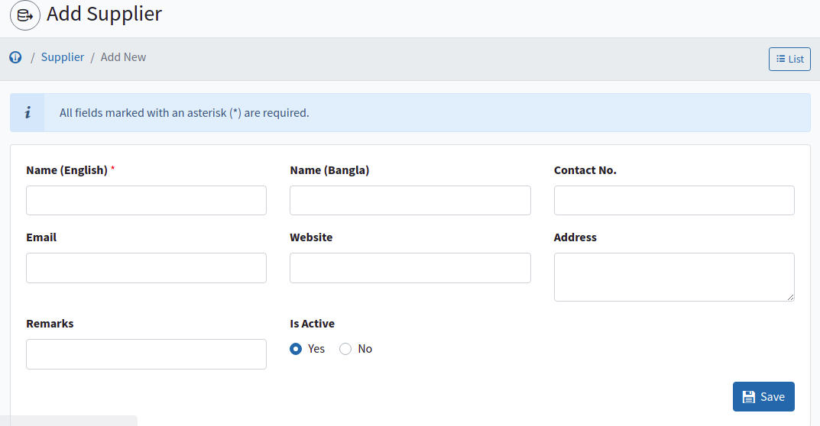

Figure 5.13: Supplier List and Entry Screen

**Stock Report:** The following figure 5.14 and 5.15 shows that Item stock quantity with custodian wise or department stock. We can export report as PDF, XLS or Word File

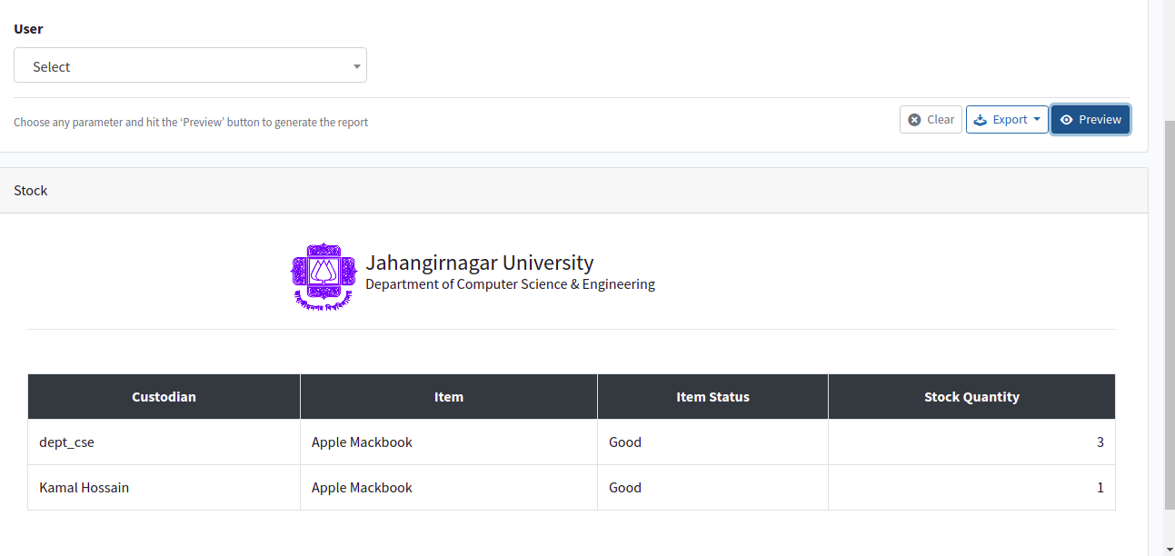

Figure 14: Stock Report

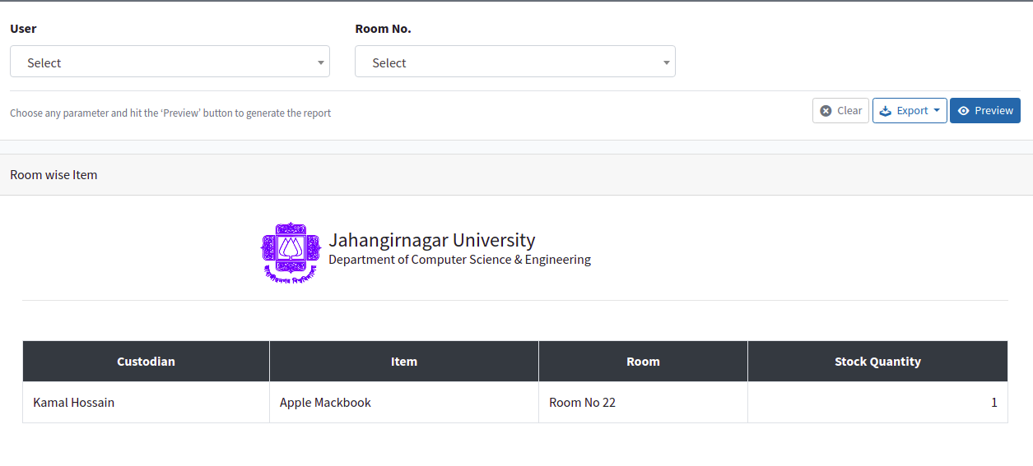Figure 5.15: Room Wise Item Stock Report

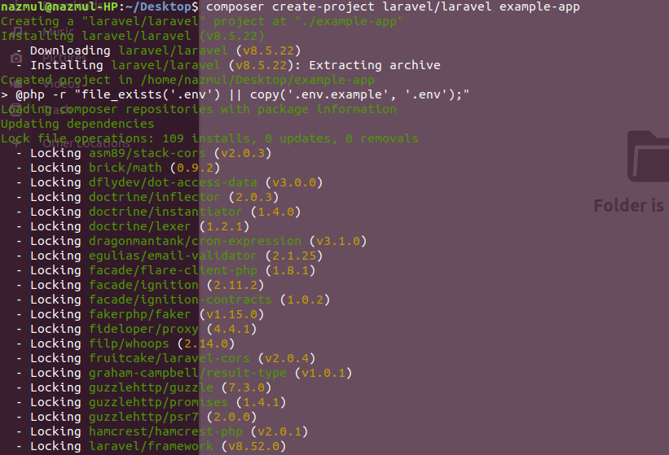

Figure 5.16: PHP Laravel Framework setup and configuration project.

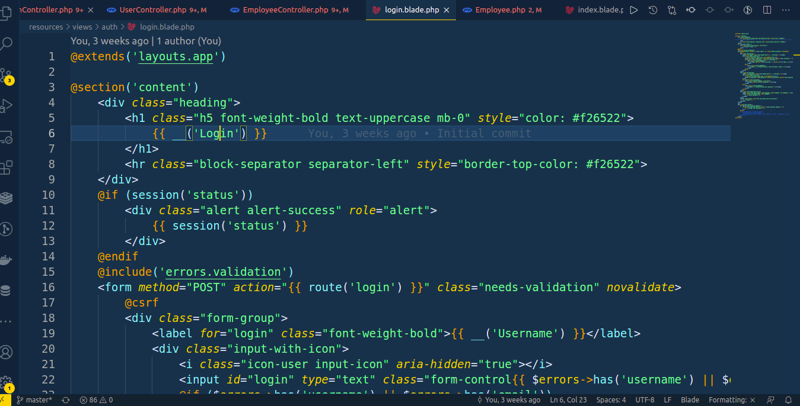Figure 5.17: Login page design with Laravel Blade Template, Html, CSS.

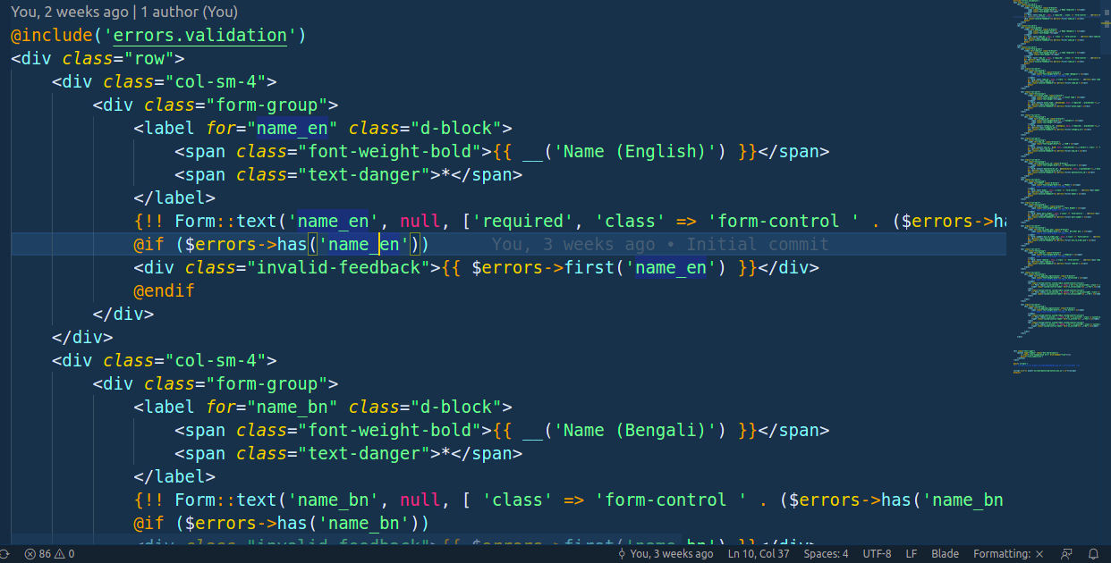

Figure 5.18: Item information entry page designing

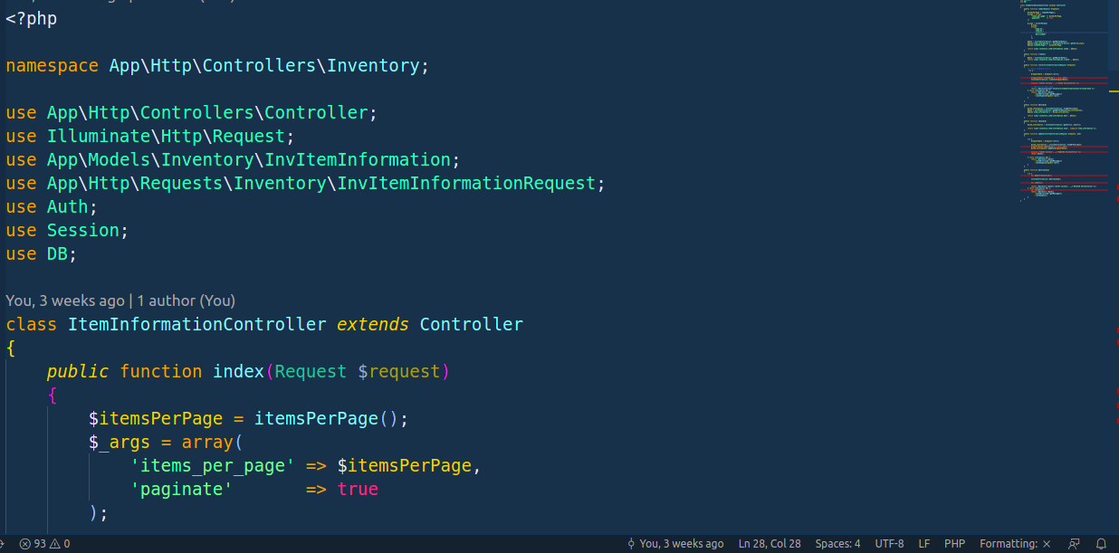

Figure 5.19: Item Information Backend PHP Controller Class php file

**5.6: Identify testers: Listen to them and incorporate relevant feedback**

All feedbacks are incorporated basically these raised from application testing. Given below the overall feedbacks categories

1. UI feedback
2. Feedback based on functionalities.
3. Database level feedback

End Users Feedback: Basically, when I will release this application then end users feedback need to incorporate to the system

**5.7: Release/Deploy the application**

App will release to Organization provided Hosting Server .

**5.8: Upgrade application with improvements and new features**

After release, the application. Based on users demand new module or existing module enhancement and further deploy as a new version.

Chapter 6

**Conclusion**

**6.1 Conclusion**

Inventory system is an important area in the asset management. It is quite susceptible to control and a very large amount of scientific models are available in the literature to enable us to choose an optimal inventory policy. Finally My Developed Inventory Management System(IMS) will be helpful for the department to manage asset distribution. When any teacher or any other employee need an Item such as a Laptop, Mouse, Chair, Table etc. They easily request for that Item through application. Management easily can know their all other Item in their stock or which item allocated to which employee easily from stock report in our Inventory System.

# **6.2 future work**

There is many more scope to improve in the application. It’s not possible to improve all the best at the first attempt. In this application also, there are so many scope to improve. Also the user experience will be considered. The most important future work that I’ll do.

* **Item disposal Information:**

In this version of the application I didn’t implement the Item disposal information scope. I have plan to do it the next version.

* **Notification system added to the system:**

When anyone request for an Item, Then Inventory manager get notification

* **Item transfer from One department to another department.**

I have plan to do it the next version

* **Item transfer receive from another department:**

I have plan to do it the next version.

# **References**

1. Lynn Beighley & Michael Morrison, 2008 “Head First PHP & MySQL” 2nd Edition O'Reilly Media, Inc.
2. Daginn Reiersol, Chris Shiflett, and Marcus Baker, 2007 “PHP In Action:

Objects, Design, Agility” 1st Edition Manning Publications.

1. Erich Gamma, Richard Helm, Ralph Johnson, John Vlissides, 1994 “Design Patterns: Elements of Reusable Object-Oriented Software” Addison-Wesley Professionala.
2. Abraham Silberschatz, Henry F. Korth, S. Sudarshan, 2011, “DATABASE SYSTEM CONCEPTS” 6th Edition McGraw-Hill.
3. Sikha Bagui and Richard Earp, 2012, “Database Design Using EntityRelationship Diagrams” 2nd Edition CRC Press
4. “Development of inventory management system”, Conference paper - 16-18 April 2010 [June 1, 2021]
5. “PHP Manual”, Internet: <https://www.php.net/manual/en/index.php>, January 10, 2001 [May 01, 2021].
6. “Laravel”, Internet: https://laravel.com/docs/8.x, June 09, 2011

[June 01, 2021].

1. “The Apache, HTTP Server Project”, Internet: https://httpd.apache.org, April 1995 [April 01, 2021].
2. “Ultimate Entity Relationship Diagram Tutorial (ER Diagrams)”, Internet:<https://creately.com/blog/diagrams/er-diagrams-tutorial>, March 14 2021 [July 01 2021]
3. “Design Pattern Overview”, Internet: https://www.tutorialspoint.com/design_pattern/design_pattern_overview.htm, [July 01, 2021].
4. “Study on a New System for Inventory Control”, Conference paper - 20-22 October 2008 [June 1, 2021].
5. “World Wide Web”, Internet: <https://developer.mozilla.org/en-US/docs/Glossary/World_Wide_Web>, July 23, 2021 [July 24, 2021]
6. "Performance evaluation of HTTP/TCP on asymmetric networks”, Internet:<https://www.researchgate.net/publication/2925201_Performance_Evaluation_of_HTTPTCP>, May, 2004 [July 10, 2021]
7. “Formal Analysis of Use Case Diagrams”, Research Gate, Computer Science, Volumn: 11, January 11, 2010 [Jun 20, 2021].
8. “Complete Tutorials of PHP OOP Classes/Objects with Example code”, Internet:<https://www.devopsschool.com/blog/complete-tutorials-of-php-oop-classes-objects-with-example-code>, May 31, 2021 [June 02, 2021].
9. “Pattern-based Analysis of UML Activity Diagrams”, Internet:https://www.researchgate.net/publication/228913582_Pattern-based_Analysis_of_UML_Activity_Diagrams, January 2004 [July 10, 2021]